CS 148

Kyra Bevins

Assignment: Final Project – Assignment 10

Bibliophilia – Book Reviews Website

Version <1.0>

Table Of Contents

Time Log 3

Introduction 4

Purpose 4

Definitions, acronyms, and abbreviations 4

Story Board 5

Assignment requirements 6

Specific requirements 7

**ERD and Data Dictionary ………………………………………………………………………………..8**

**Schema …………………………………………………………………………………………………………...9**

|  |  |  |  |
| --- | --- | --- | --- |
| Time Log | | | |
| Estimated time to complete assignment => | | | 100Hours |
| Date | Time Spent  (in hours) | Description | Author |
| 11/09/15 | 2 | Created Books Database, and three tables | Kyra Bevins |
| 11/10/15 | 2 | Attempting to figure out form/Brainstorming pages | Kyra Bevins |
| 11/11/15 | 8 | Worked on reviews, rating, users pages, plus CSS, | Kyra Bevins |
| 11/13/05 | 3 | Worked on php for users page, worked on genres page | Kyra Bevins |
| 11/15/05 | 8 | Worked on form | Kyra Bevins |
| 11/16/05 | 6 | Worked on form | Kyra Bevins |
| 11/18/05 | 6 | Worked on form - editing | Kyra Bevins |
| 11/18/05 | 8 | Worked on form – editing | Kyra Bevins |
| 11/23/05 | 7 | Worked on form – adding | Kyra Bevins |
| 11/25/05 | 2 | Worked on form - deletion | Kyra Bevins |
| 11/26/05 | 4 | Basic touches | Kyra Bevins |
| 11/27/05 | 8 | Finalizing everything | Kyra Bevins |
| 12/1/2015 | 4 | Final touches & Css | Kyra Bevins |
|  |  |  |  |
|  |  |  |  |
|  |  |  |  |
|  |  |  |  |
|  |  |  |  |
|  |  |  |  |
|  |  |  |  |
|  |  |  |  |
|  | 70 | <=Total Time Spent |  |
|  |  |  |  |

# Introduction

### Purpose

The purpose of this document is to describe the requirement specification for the web site “Bibliophilia”.

The intended audience for this document is anyone interested in seeing how this website will be developed and plans for what I will be delivering through this site. It is also for myself, the developer, so that I have a better understanding of what I will be creating.

### Definitions, acronyms, and abbreviations

*Sample for the client:*

HTML – Hypertext markup language – used to define your content.

PHP – Personal Home Page – language that helps to customize html.

CSS – Cascading Style Sheets – used to define the look of a web site.

W3 Validation – refers to both Html and CSS validation tool provided by the W3c.org. the html validator is located at:

<http://validator.w3.org/>

with the CSS validator located at:

<http://jigsaw.w3.org/css-validator/>

# 

# Story Board

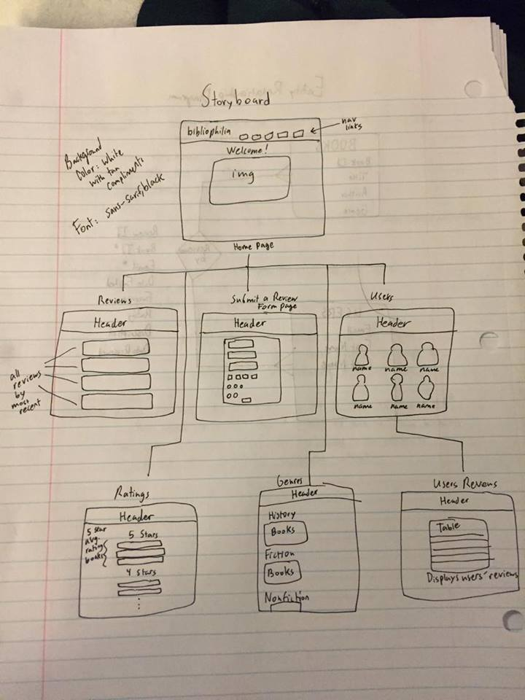

# Specific requirements

1. *Title :* Bibliophilia
2. *Meta Description*: Allows users to add books that they have read and what they thought of them.
3. *Meta Character set*: UTF - 8
4. *Logo*: 
5. *Content can be found here*: books of all kinds of genres, along with users of the site, and their reviews of the books.

**Entity Relationship Diagram:**

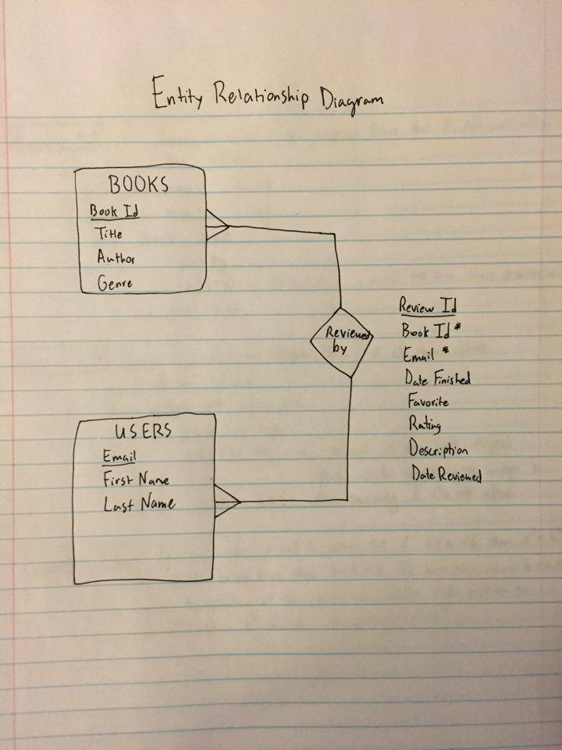

**Data Dictionary:**

## tblBooks

|  |  |  |  |  |  |
| --- | --- | --- | --- | --- | --- |
| **Column** | **Type** | **Null** | **Default** | **Comments** | **MIME** |
| pmkBookId | int(11) | No |  |  |  |
| fldTitle | varchar(40) | No |  |  |  |
| fldAuthor | varchar(40) | No |  |  |  |
| fldGenre | varchar(40) | No |  |  |  |

### Indexes

| **Keyname** | **Type** | **Unique** | **Packed** | **Column** | **Cardinality** | **Collation** | **Null** | **Comment** |
| --- | --- | --- | --- | --- | --- | --- | --- | --- |
| PRIMARY | BTREE | Yes | No | pmkBookId | 8 | A | No |  |

## tblUsers

|  |  |  |  |  |  |
| --- | --- | --- | --- | --- | --- |
| **Column** | **Type** | **Null** | **Default** | **Comments** | **MIME** |
| pmkEmail | varchar(30) | No |  |  |  |
| fldFirstName | varchar(30) | No |  |  |  |
| fldLastName | varchar(30) | No |  |  |  |

### Indexes

| **Keyname** | **Type** | **Unique** | **Packed** | **Column** | **Cardinality** | **Collation** | **Null** | **Comment** |
| --- | --- | --- | --- | --- | --- | --- | --- | --- |
| PRIMARY | BTREE | Yes | No | pmkEmail | 2 | A | No |  |

## tblUsersBooks

|  |  |  |  |  |  |
| --- | --- | --- | --- | --- | --- |
| **Column** | **Type** | **Null** | **Default** | **Comments** | **MIME** |
| fnkBookId | int(11) | No |  |  |  |
| fnkEmail | varchar(30) | No |  |  |  |
| fldDateFinished | date | No |  |  |  |
| fldFavorite | tinytext | Yes | *NULL* |  |  |
| fldRating | int(1) | No |  |  |  |
| fldDescription | longtext | No |  |  |  |
| fldDateReviewed | timestamp | No | CURRENT_TIMESTAMP |  |  |
| pmkReviewId | int(11) | No |  |  |  |

### Indexes

| **Keyname** | **Type** | **Unique** | **Packed** | **Column** | **Cardinality** | **Collation** | **Null** | **Comment** |
| --- | --- | --- | --- | --- | --- | --- | --- | --- |
| PRIMARY | BTREE | Yes | No | pmkReviewId | 3 | A | No |  |

**Schema:**

Books Table:

CREATE TABLE IF NOT EXISTS `tblBooks` (

`pmkBookId` int(11) NOT NULL,

`fldTitle` varchar(40) NOT NULL,

`fldAuthor` varchar(40) NOT NULL,

`fldGenre` varchar(40) NOT NULL

) ENGINE=InnoDB AUTO_INCREMENT=55 DEFAULT CHARSET=utf8;

Users Books Tables:

CREATE TABLE IF NOT EXISTS `tblUsersBooks` (

`fnkBookId` int(11) NOT NULL,

`fnkEmail` varchar(30) NOT NULL,

`fldDateFinished` date NOT NULL,

`fldFavorite` tinytext,

`fldRating` int(1) NOT NULL,

`fldDescription` longtext NOT NULL,

`fldDateReviewed` timestamp NOT NULL DEFAULT CURRENT_TIMESTAMP ON UPDATE CURRENT_TIMESTAMP,

`pmkReviewId` int(11) NOT NULL

) ENGINE=InnoDB AUTO_INCREMENT=23 DEFAULT CHARSET=utf8;

User’s Tables:

CREATE TABLE IF NOT EXISTS `tblUsers` (

`pmkEmail` varchar(30) NOT NULL,

`fldFirstName` varchar(30) NOT NULL,

`fldLastName` varchar(30) NOT NULL

) ENGINE=InnoDB DEFAULT CHARSET=utf8;